**NAME:………………………………………….. INDEX NO……………………….………….**  
**SCHOOL:……………………………………… CANDIDATE’S SIGN ……………..**

**DATE………**

443/1

**AGRICULTURE**

**Paper 1**

FORM 3

**DECEMBER HOLYDAY ASSIGNMENT**

**INSTRUCTIONS TO THE CANDIDATES**

* This paper consists of ***three****sections*, A, B and C.
* Answer ***all*** *questions*in section ***A and B.***
* Answer ***any****2* questions from section ***C.***

SECTION A (30 MRKS)

Answer all question in this section in the space provided

1. Differentiate between olericulture and pomoculture as used in crop production . (1mrk)
2. List the physical weathering agents in soil formation process (1 ½ mrks)
3. Give four method of farming (2mrks)
4. Give four advantages of crop rotation . (2mrk)
5. State four factors that that should be considered when classifying crop pest (2mrks)
6. Give three reasons why a water logged soil is unsuitable for most crops (1 ½ mks)
7. Outline **four** advantages of tissue culture (2 marks)
8. Name any **four** farming practices used to achieve minimum tillage. (2 marks)
9. State **four** factors that determine the choice of irrigation method to be used in the farm. (2 marks)
10. Name **two** liming elements in crop production. (1 mark)
11. Outline **four** factors that determine the depth at which seeds are planted. (2 marks)
12. Give any **three** tertiary operations carried out during land preparation. (1 ½mks)
13. State **four** symptoms of viral disease attack in crops. 2mks
14. State **three** forms in which soil water exists. (1 ½ mks)

1. In farming under what conditions is opportunity cost zero. (1mk)

1. Name the vegetative materials used in the establishment of the following crops.

Bananas ……………………………………………………………………………………..(½ mk)

Pineapples……………………………………………………………………………………(½ mk)

Sisal ………………………………………………………………………………………… (½ mk)

1. State **four** advantages for planting potatoes in a ridged seedbed. (2mks)

1. State **four** reasons for pruning. (2mks)

19. Give reasons for carrying each of the following practices in tomatoes nursery. (2mks)

**(i) Pricking out**

**(ii) Hardening off**

**SECTION B (20 MRKS**)

Answer all the questions in this section in the spaces provided

20 Study the illustration given below representing crop pest and answer the questions that follow.

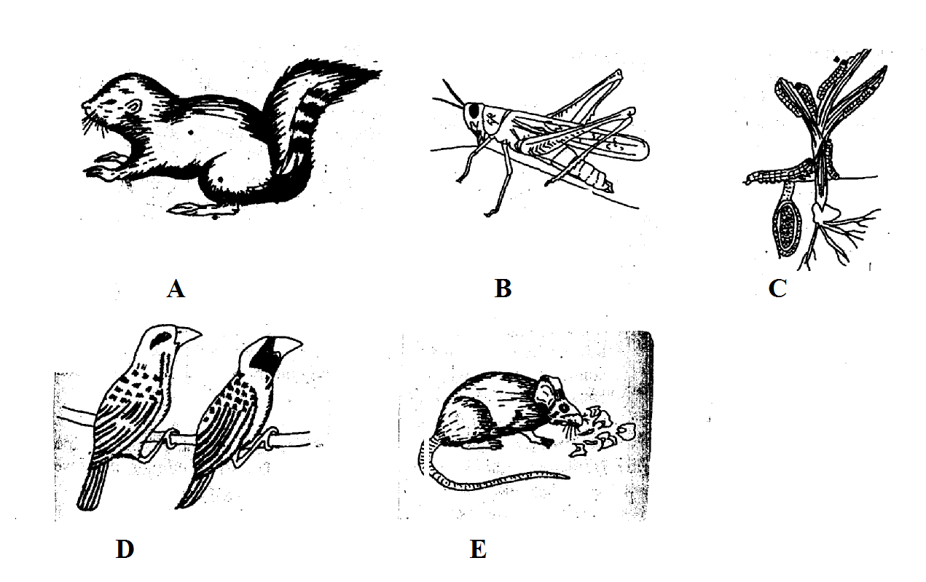

i) Identify the pest represented by A,C,D and E. 2mks

ii) Name a crop disease that is spread by pest labelled B. 1mk

iii) Name **two** damages caused by pest E. 1mk

iv) Give **two** control measures for the pest labelled D. 1mk

21 The following is a diagram of maize cob attacked by disease.

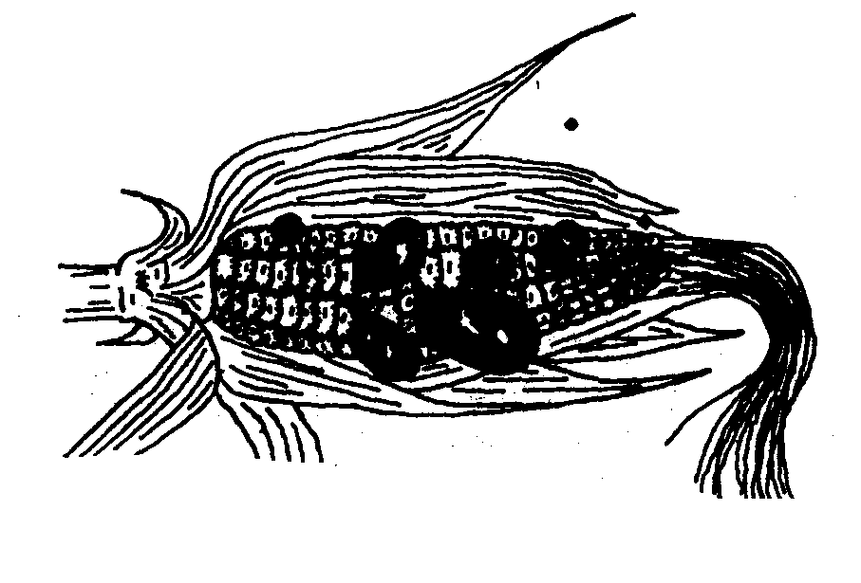

i) Identify the disease. 1mk

ii) List **three** control measures of the above disease. 11/2mks

iii) Name **one** other crop attacked by similar disease. ½ mk

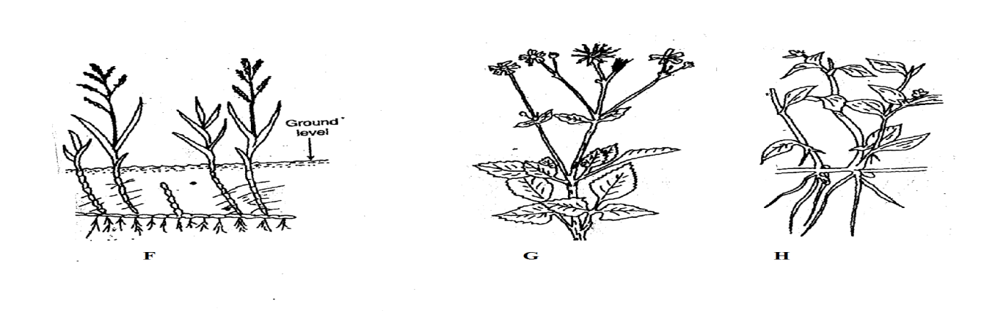22 The diagrams F,G and H above show weeds

i) Identify the weeds labelled F,G and H.

F - ……………………………………………………. ½ mk

G - ………………………………………………….. ½ mk

H - ……………………………………………………….. ½ mk

ii) Why is it difficult to control weed labelled F. 1mk

……………………………………………………………………………………………………………………………………………………………………………………………………………...

23 The diagram below illustrates a field practice study it carefully and answer the questions that follow.

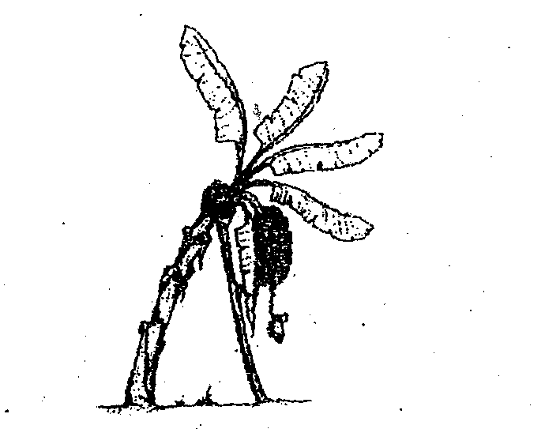

a) Name the practice. ½ mk

……………………………………………………………………………………………………...

b) Give **three** reasons for carrying out the practices named in (a) above. 3mks

1. The diagram below shows a method of layering. Study it and answer the questions that follow.

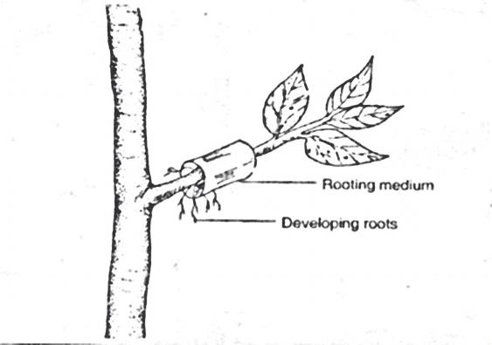

1. Identify the method of layering illustrated above. (1 mark)

___________________________________________________________________________________

1. State **one** circumstance in which the method of layering indicated above is recommended. (1 mark)

______________________________________________________________________________________________________________________________________________________________________

1. a) Maize requires 120kg/ha of phosphorus pentoxide (P2O5). How much of the compound

fertilizer20:20:10 would be applied to 0.4 hectare of land to achieve this rate.

(show your working). (2 marks)

26. Study the diagram below carefully and answer the questions that follow.

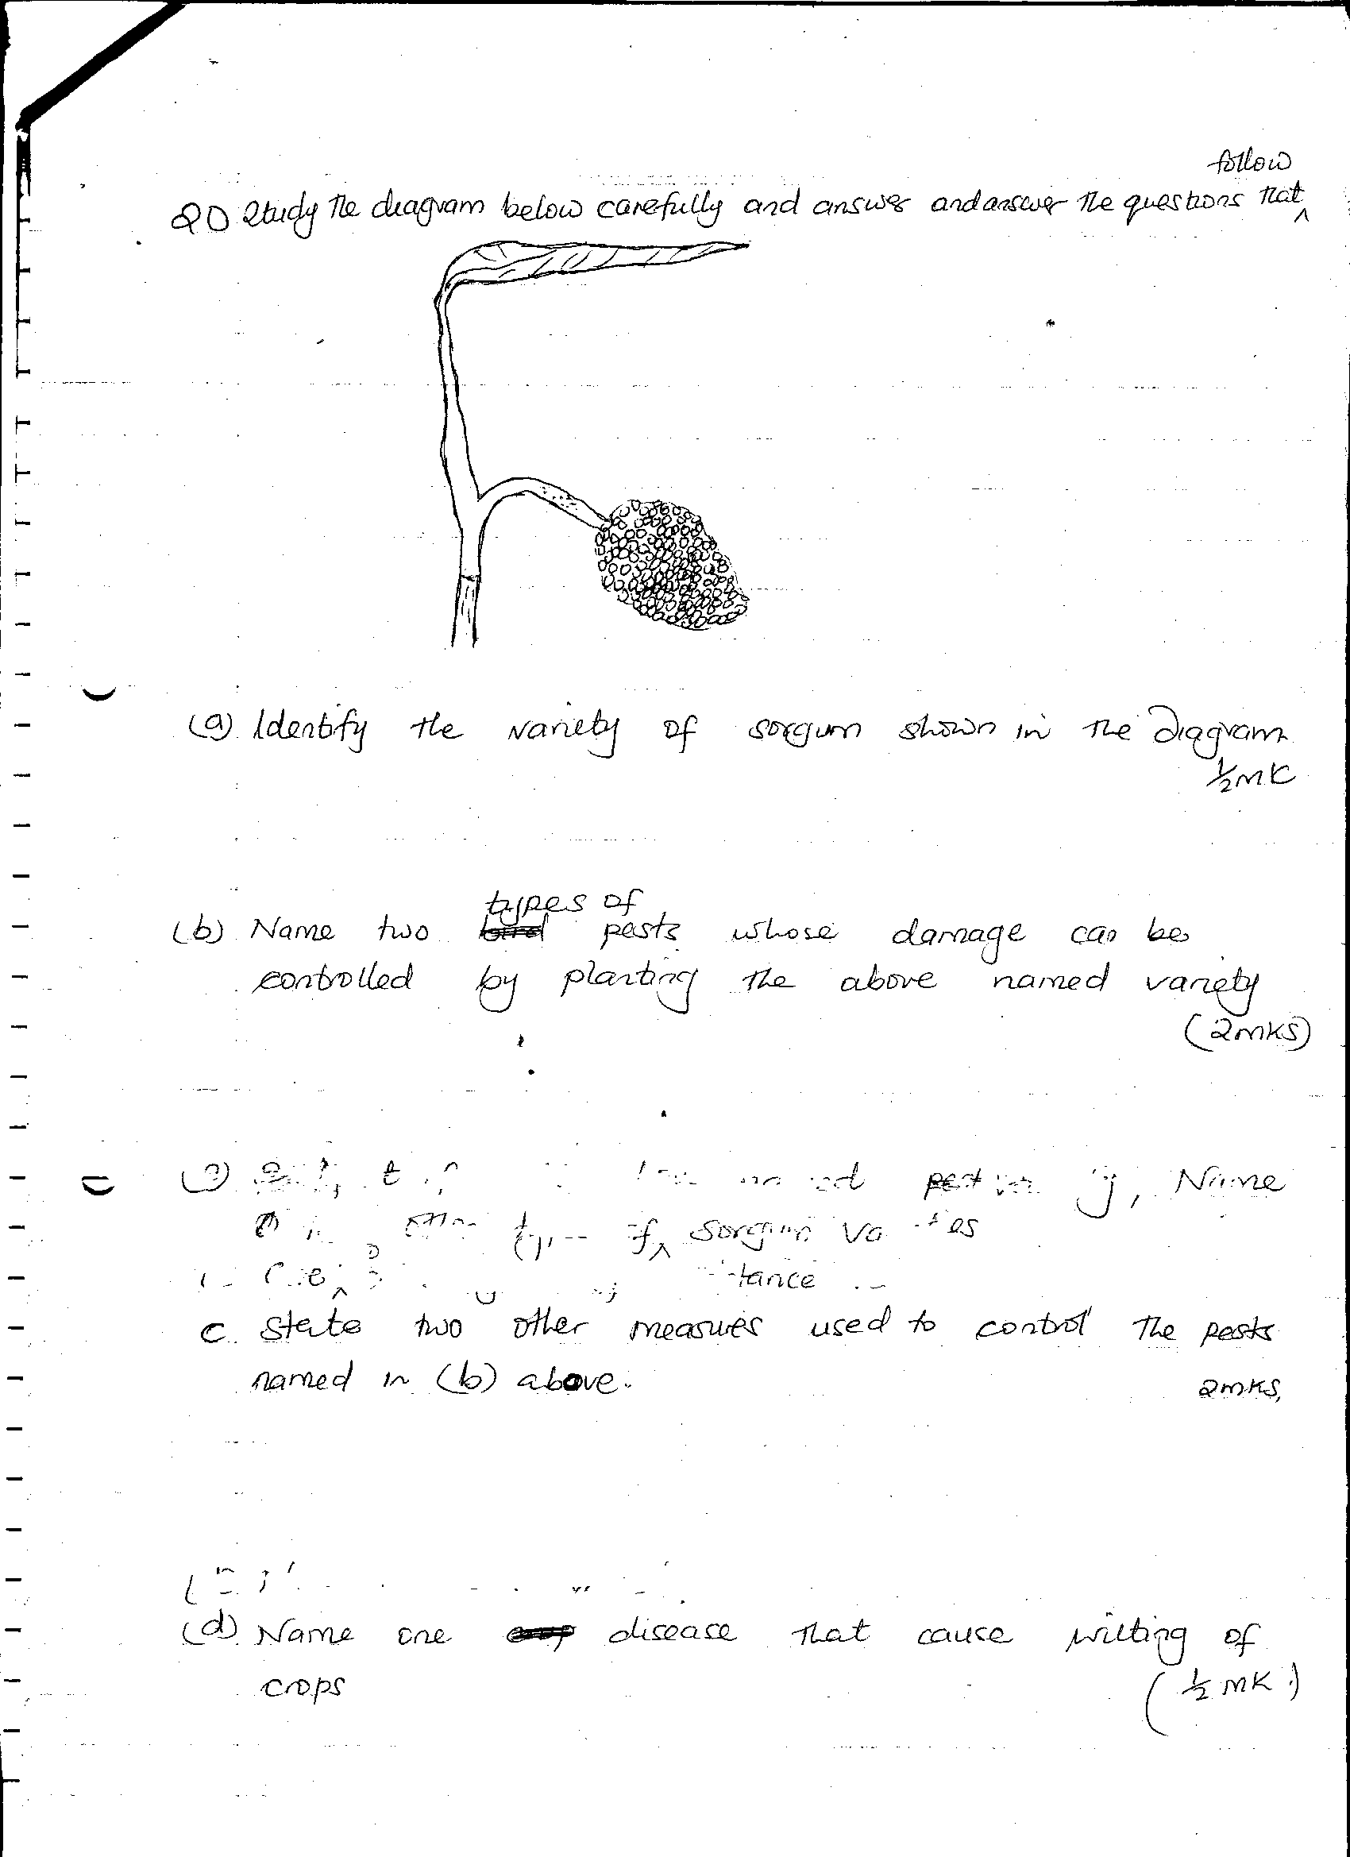

1. Identify the variety of sorghum shown in the diagram. 1mk

________________________________________________________________________________________________________________________________________________

1. Name two types of pests whose damage can be controlled by planting the above named variety. 2mks

________________________________________________________________________________________________________________________________________________________________________________________________________________________

1. State two other measures used to control the pests named in (b) above. 2mks

**SECTION C (40MARKS)**

***Answer only two question in this section in the spaces provided***

27. (a) Describe the field production of dry beans under the following subheadings:

(i) Varieties (2marks)

(ii) Land preparation (3marks)

(iii) Planting (4marks)

(iv) Field management practices and harvesting (6marks)

(b)Explain **five** post harvest practices in grains before processing (5marks)

28. (a)Describe the stages of chemical water treatment for human consumption (6marks)

(b) Describe **four** methods of draining marshy land for pasture production (4marks)

(c) State **five** physical methods of soil and water conservation carried out on arable land with 20% slope.

Explain how each method works. (10marks)

29. (a) Describe the cultural methods used to control pest in the farm. (10mks)

(b) Explain the problems associated with land fragmentation. (10mks)